**Capstone Project**

**Introduction**

I would like to open a hotel/restaurant near beach side. As it is a famous tourist spot, there is already lots of attention towards it. I know there will be many competitors in terms of hotel and restaurant. But keeping them in mind, need to locate my hotel in place where more people are attracted and comfortable for a stay and a good meal. I want to bring foreign and local people’s attention towards my new hotel. I would like to flavor my restaurant recipe with Italian, American, typical south & north Indian foods to grab their taste.

The challenge is to find a suitable location for opening a new hotel / restaurant attracted to all local and foreign people in the center of all famous venues.

**Data**

We will be completely working on Foursquare data to explore and try to locate our new hotel where more venues like church, temples, beach, museums, memorials that are present nearby.

We will looking for midpoint area of venues to locate our new hotel. Before that our major focus will be on all venues present in and around the core place of Kanyakumari. Just a heads up on how many hotels are distributed now around Kanyakumari. We will perform some EDA on hotels & restaurants present in the tourist spot. On further notebook we will use Foursquare data to determine other venues as well.

**Methodology**

In this section we will perform some data analysis and EDA to find insight from data. We try to understand the current stats of all given data. Probably clustering or centroid of all venues will help us to locate new hotel.

* Identify how far are hotels from the core location

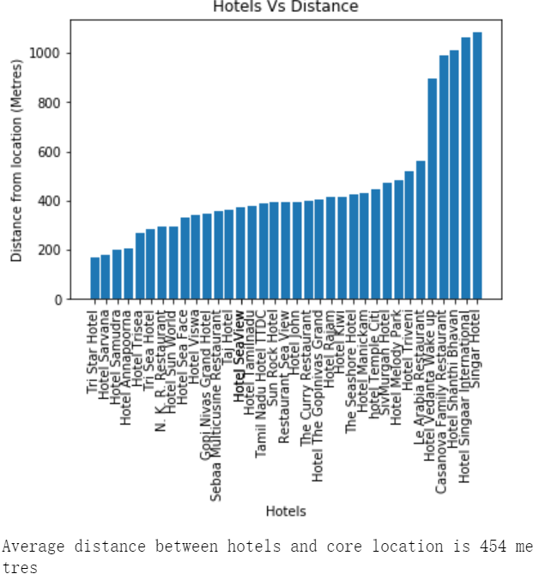

* Explore for other venues around Kanyakumari

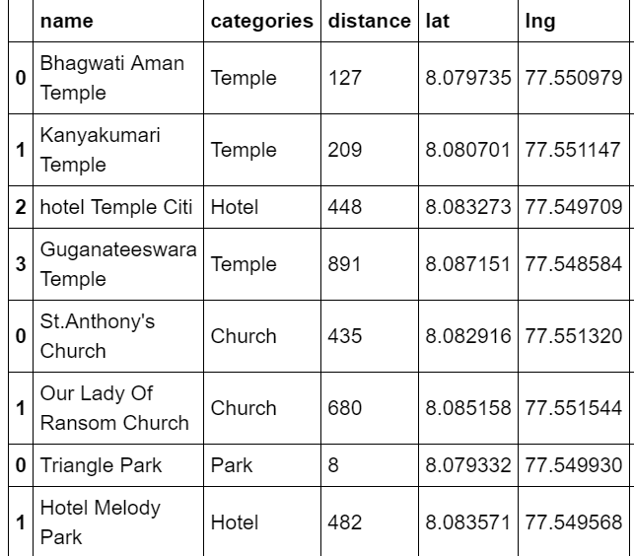

* Extract Venues using Search Queries¶
* Get location of all venues and store data in a dataframe
* How far are venues from the core location

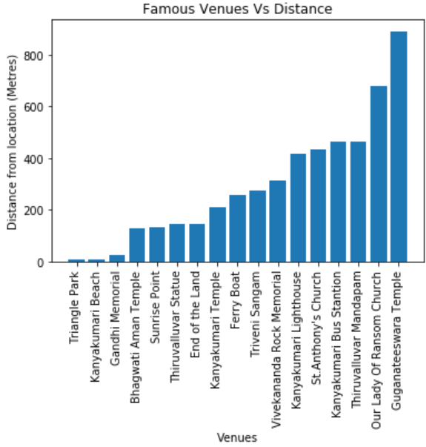

* Visualizing venue categories

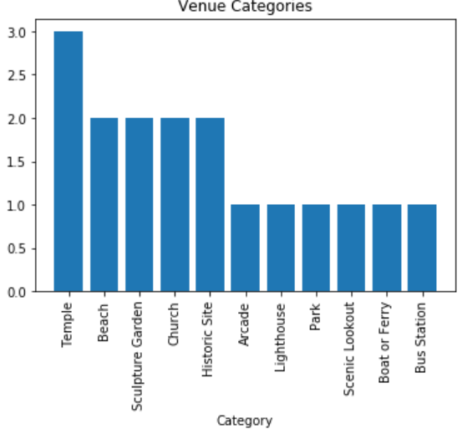

* Show rating of all venues

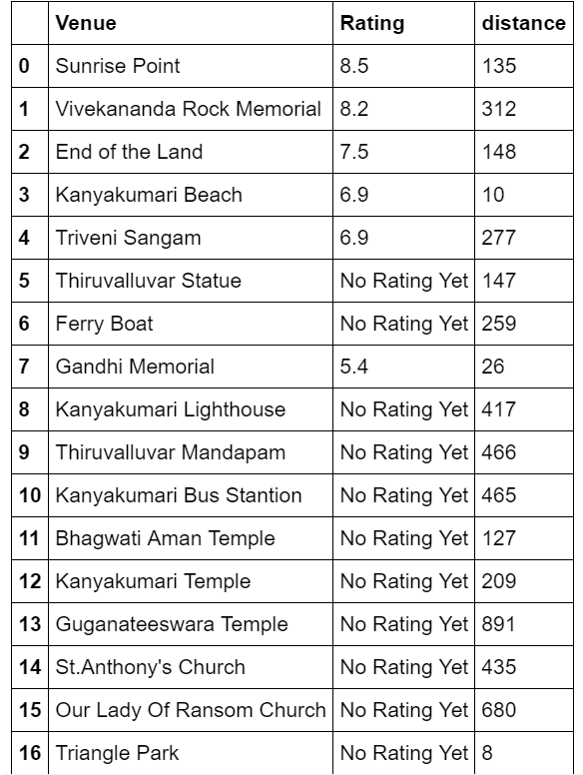

* Get number of tips for all venues

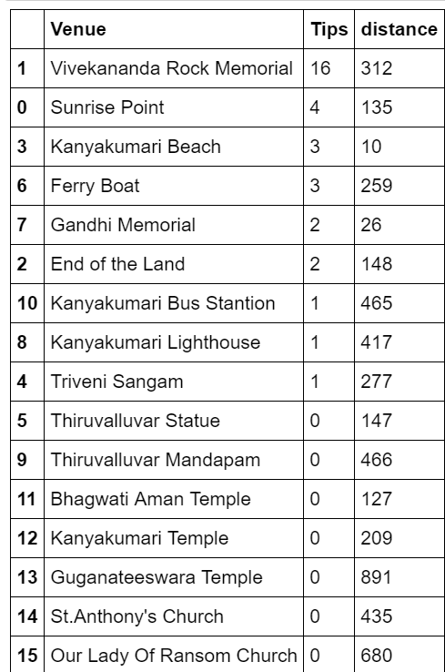

* Extract rated and tips venues

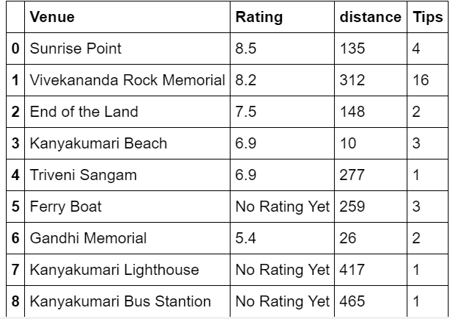

* Construct a final list of venues

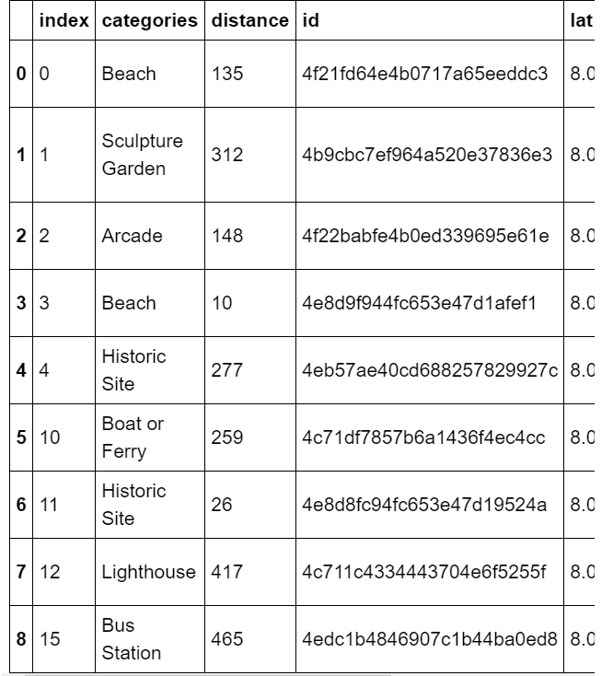

* Final clustering based on venues

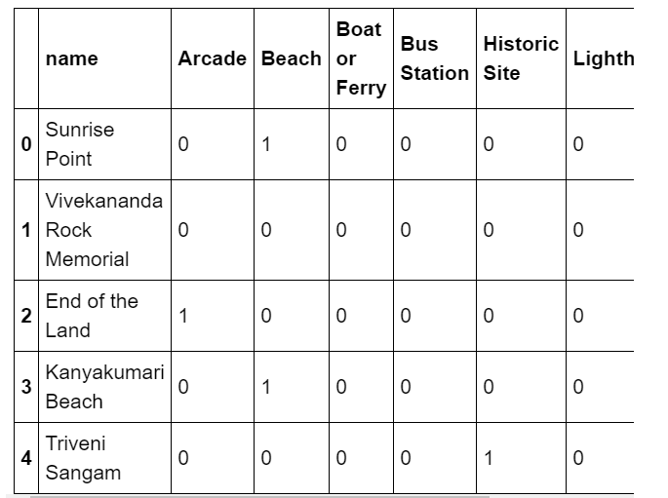

* Center of all clusters and midpoint of all venues\

**Result**

*My hotel location*

* Final location is pointed at **8.07985,77.54973**
* This location is **at Beach Road opposite to Gandhi Memorial and Kumari Temple.**
* Located at exact junction of two cross roads which can give more attention to people who passby.

*Top rated venues*

* Sunrise Point
* Vivekananda Rock Memorial
* End of the Land
* Kanyakumari Beach
* Triveni Sangam
* Gandhi Memorial

All these venues are rated well than other and also they have more tips and located within 320 meters to core location of kanyakumari. So tourists may like to visit these places.

**Discussion**

From above reports, we could get an idea why the predicted one is pointed/clustered on the given spot. First, most thing could be the center of attraction for the place.

K-Means have figured out the most common place for all the venues. This output was very adjacent to the core location. This proves the accurate spotting of our predicted algorithm.

Despite of the findings, there were some lack in data. Tips and ratings were missing for most of the venues. Also when I compared foursquare data with google map ,i could see there were many hotels and venues found missing in foursquare.

**Conclusion**

As a business person, one would be able to set up a hotel/restaurant on given spot. This will bring revenue automatically as we have located in very near to core one. We proved this with K-means.